Emergency in Bamenda
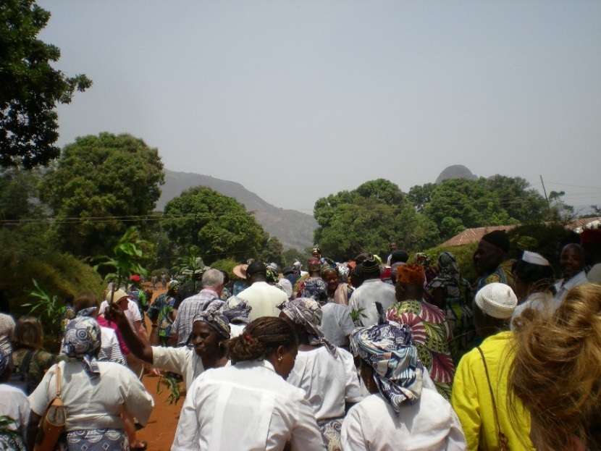
Thousands of people in our sister Diocese of Bamenda have been displaced by the ongoing crisis in the North West and South West Provinces of Cameroon and are in urgent need of help.
The Archbishop of Bamenda has established Ad Hoc Committees in each of his parishes to dispense aid directly to those who need it most.

Please help the Portsmouth Diocese Bamenda Commission to help them!
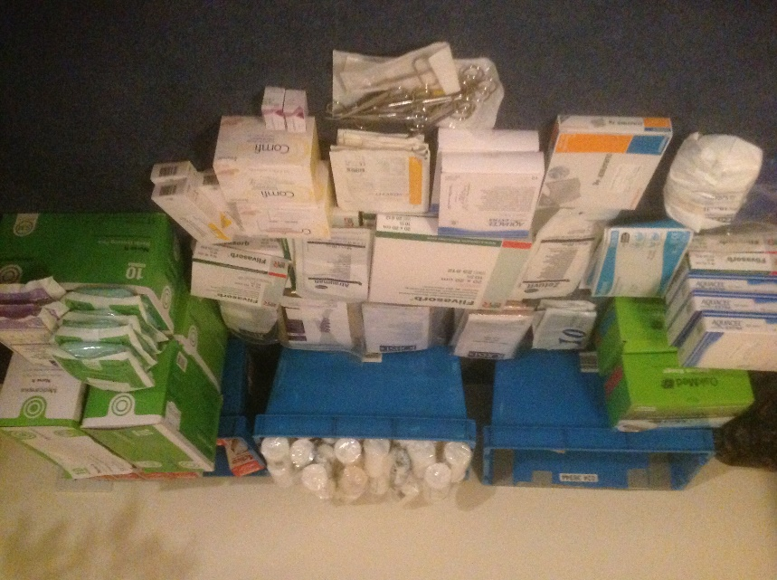
£10 can supply warm clothing
£30: a huge sack of rice
£50: a range of medical supplies such as bandages, antibiotics, painkillers
But ANY SUM would be welcomed - together, we can make a big difference!
To donate, please visit our website: www.bamendaandportsmouth.com
and click on the MyDonate button to make a secure online payment, specifying that it is for the Emergency Appeal.
Please Gift Aid your donation if you qualify to do so.
Cheques payable to ‘PRCDTR Bamenda Commission’ may be sent to: Rev G Dailly, Treasurer Bamenda Commission, 21 Beech Rd, Alresford, SO24 9JS
For further advice, please email: gdailly@portsmouthdiocese.org.uk
A publication of Portsmouth Roman Catholic Diocesan Trust. Registered Charity No: 246871

